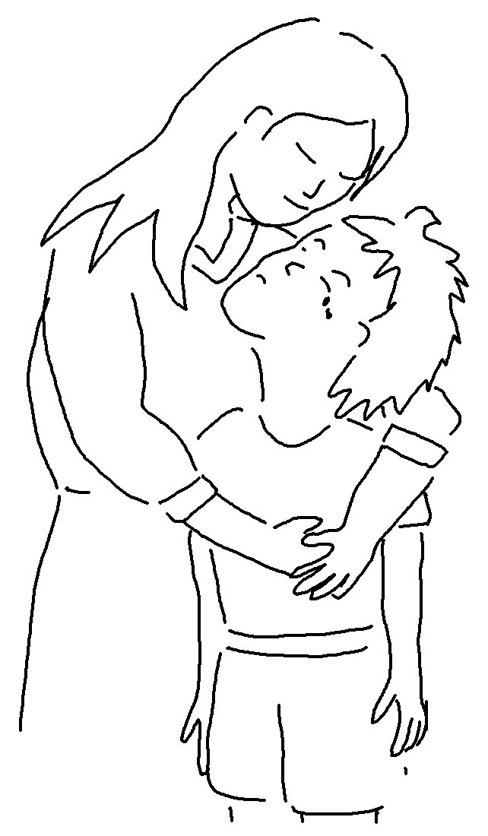
God will judge us for everything we do, including every _ _ _ _ _ _ thing, whether _ _ _ _ or _ _ _.
Ecclesiastes 12:14_{NLT}

